**Game types:**

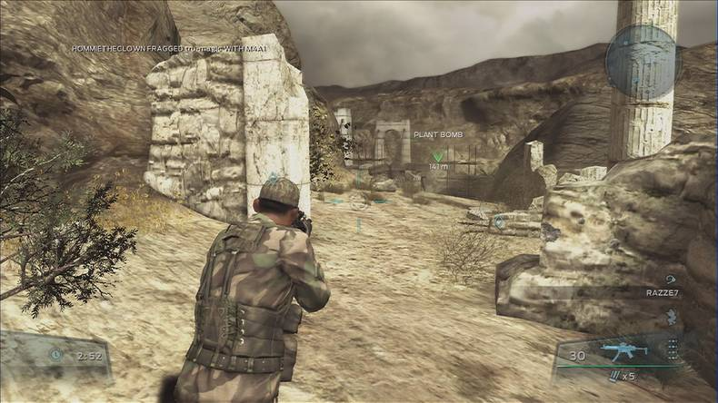Third person shooter (TPS)

“A type of video game whose gameplay involves shooting enemies and other targets and in which a player views the action as if from a position behind the character they are controlling.”

First person shooter (FPS)

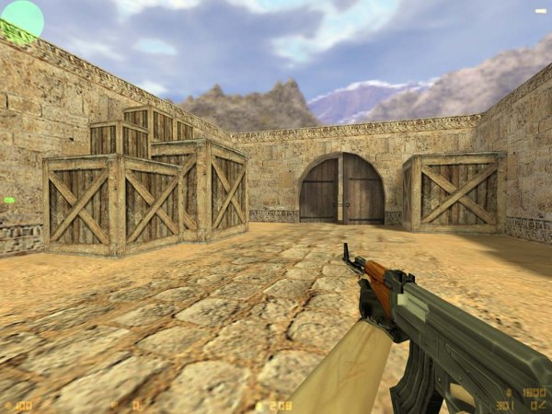“A type of video game whose gameplay involves shooting enemies and other targets and in which a player views the action as though through the eyes of the character they are controlling.”

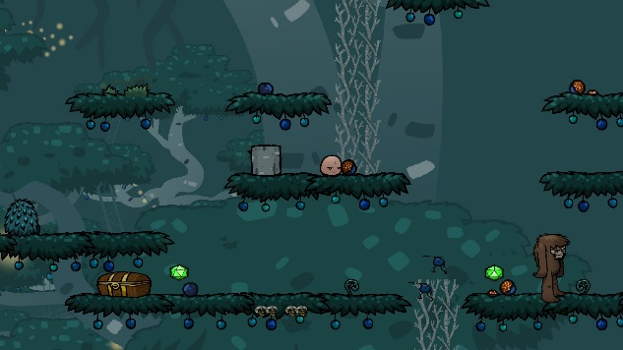2D platformer

“A type of video game whose gameplay involves guiding an avatar to jump between suspended platforms and/or over obstacles to advance the game.”

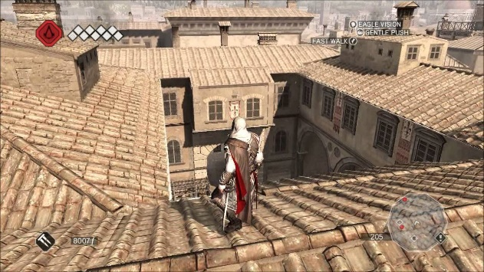3D Platformer

“A type of video game whose gameplay involves guiding an avatar to jump between suspended platforms, over obstacles, or both to advance the game. These challenges are known as jumping puzzles or free running”

Indie

“An independent video game (indie game) is a videogame that is created without the financial support of a publisher. Indie games often focus on innovation and rely on digital distribution.”

Action

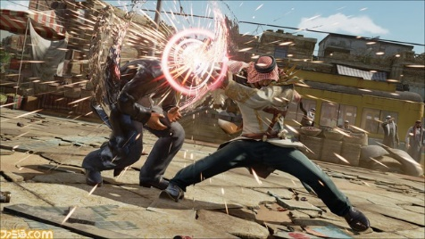“A type of video game whose gameplay emphasizes physical challenges, including hand–eye coordination and reaction-time.”

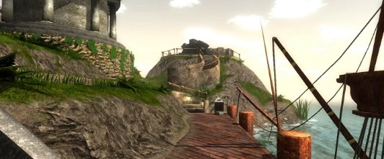Adventure

“a type of video game in which the participant plays a fantasy role in an episodic adventure story”

Casual

“A casual game is a video game targeted at or used by a mass audience of casual gamers. Casual games can have any type of gameplay, and fit in any genre. They are typically distinguished by their simple rules and lack of commitment required in contrast to more complex hardcore games.”

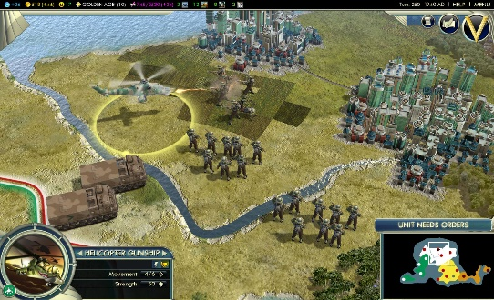 Strategy

“A strategy game is a game in which the players' uncoerced, and often autonomous decision-making skills have a high significance in determining the outcome. Almost all strategy games require internal decision tree style thinking, and typically very high situational awareness.”

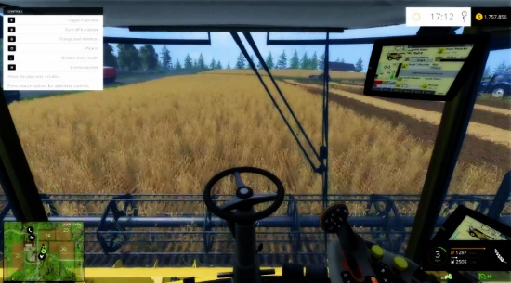Simulation

“A simulation video game describes a diverse super-category of video games, generally designed to closely simulate aspects of a real or fictional reality. Asimulation game attempts to copy various activities from real life in the form of a game for various purposes such as training, analysis, or prediction.”

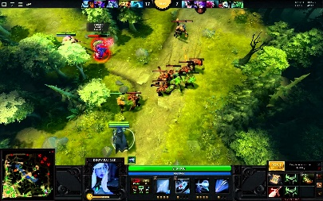RPG

“A role-playing video game (RPG), or computer role-playing game (CRPG) is a video game genre where the player controls the actions of a character (and/or several party members) immersed in some well-defined world.”

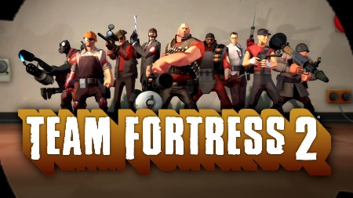Free To Play

“Free to play (F2P) refers to a business model for online games in which the game designers do not charge the user or player in order to join the game. Instead, they hope to bring in revenue from advertisements or in-game sales, such as payment for upgrades, special abilities, special items, and expansion packs.”

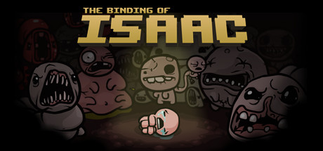Single player

“denoting or relating to a video game designed for one player only.”

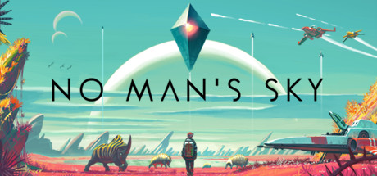Massively Multiplayer

“A massively multiplayer online game (MMOG or MMO) is an online game which is capable of supporting large numbers of players, typically from hundreds to thousands, simultaneously in the same instance (or world). MMOs usually feature a huge, persistent open world, although some games differ.”

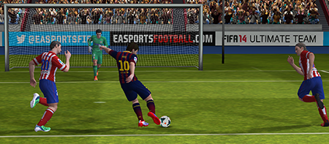Sport

“A sports game is a video game that simulates the practice of sports. Most sports have been recreated with a game, including team sports, track and field, extreme sports and combat sports.”

Racing

 “The racing video game genre is the genre of video games, either in the first-person or third-person perspective, in which the player partakes in a racing competition with any type of land, air, or sea vehicles.”

Multiplayer

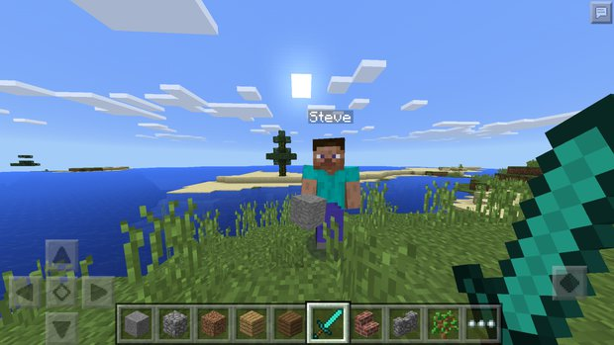 “A multiplayer video game is a video game in which more than one person can play in the same game environment at the same time. Video games are often single-player activities, putting the player against preprogrammed challenges or AI-controlled opponents (which lack the flexibility of human thought).”

Sound

“games with enhanced sound”

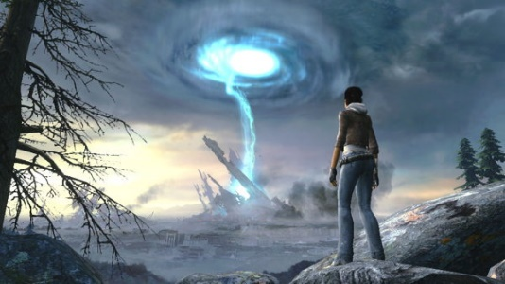Atmospheric

“games with powerful atmospheres, often very realistic graphics.”

Puzzle

“Puzzle video games are a genre of video games that emphasize puzzle solving. The types of puzzles can test many problem-solving skills including logic, pattern recognition, sequence solving, and word completion.”

Horror

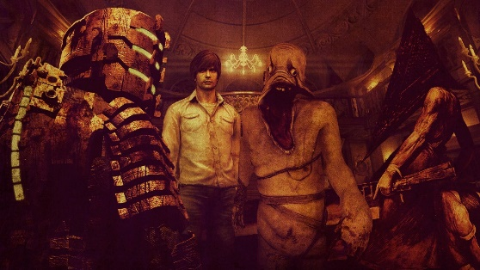 “Survival horror is a subgenre of video games inspired by horror fiction that focuses on survival of the character as the game tries to frighten players with either horror graphics or scary ambience. ... Still, the survival horror genre has persisted in one form or another.”

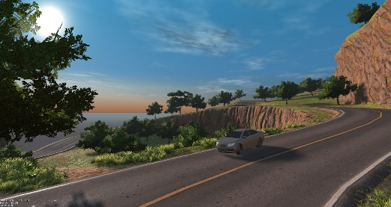Open world

“Open world, free roam, or sandbox are terms for video games where a player can move freely through a virtual world and is given considerable freedom in regard to how and when to approach particular objectives, as opposed to other video games that have a more linear structure to their gameplay.”

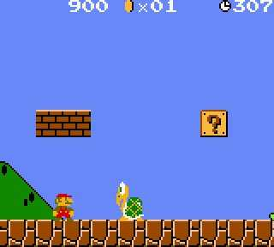2D

“Games that work of a X, Y coordinate system, and have no depth (Z)”

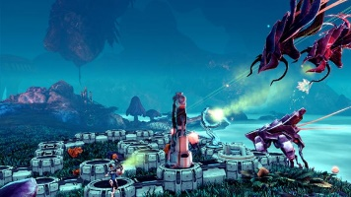Sci-Fi

“Science fiction is a genre of speculative fiction dealing with imaginative concepts such as futuristic settings, futuristic science and technology, space travel, time travel, faster than light travel, parallel universes and extra-terrestrial life.”

Co-Op

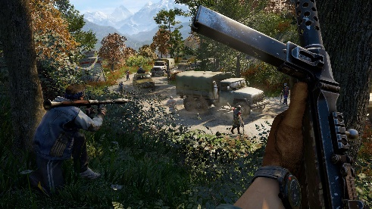 “Cooperative gameplay (co-op) is a feature in video games that allows players to work together as teammates, usually against one or more AI opponents. It is distinct from other multiplayer modes, such as competitive multiplayer modes like player versus player or death match.”

Anime

“games basted around a style of Japanese film and television animation, typically aimed at adults as well as children.”

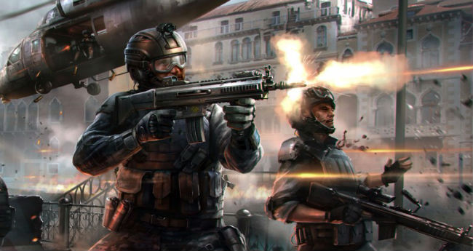Shooter

“Shooter games are a subgenre of action game, which often test the player's speed and reaction time. It includes many subgenres that have the commonality of focusing on the actions of the avatar using some sort of weapon. Usually this weapon is a gun, or some other long-range weapon.”

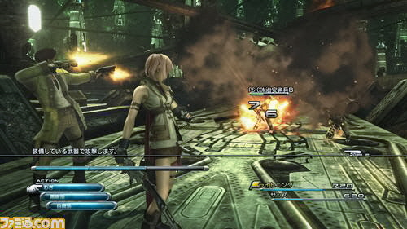Fantasy

“games based around the idea of imagining impossible or improbable things.”

Story Rich

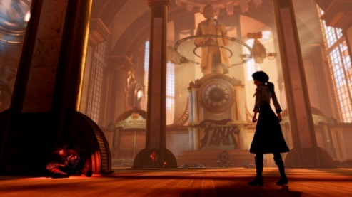 “games with strong stories behind them, possibly an understanding of a characters past.”

FPS

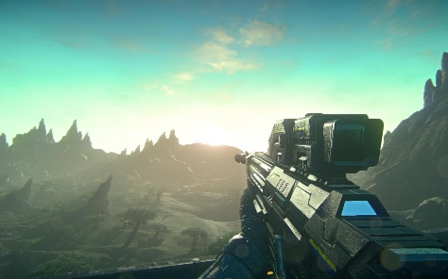 “A first person shooter (FPS) is a genre of action video game that is played from the point of view of the protagonist. FPS games typically map the gamer's movements and provide a view of what an actual person would see and do in the game.”

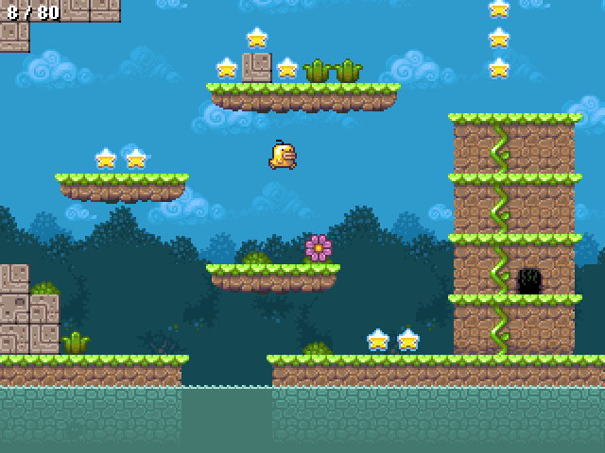Platformer

“A Platform game (or platformer) is a video game which involves guiding an avatar to jump between suspended platforms and/or over obstacles to advance the game.”

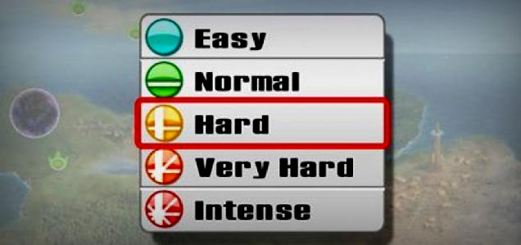Difficult

“games that require a good understanding, or a lot of skill to complete.”

Female Protagonist

“games where the main character is a female”

First Person

 “games where the view point is from the person i.e. you look through the character’s eyes.”

Funny

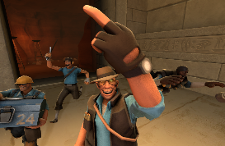 “games that try to cause laughter, amusement or are humorous.”

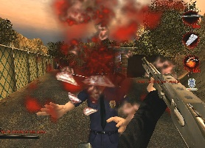Gore

“games that revolve around the idea of blood that has been shed, especially as a result of violence”

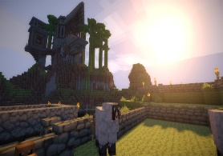Sandbox

“A sandbox is a style of game in which minimal character limitations are placed on the gamer, allowing the gamer to roam and change a virtual world at will. In contrast to a progression-style game, a sandbox game emphasizes roaming and allows a gamer to select tasks.”

Pixel graphics

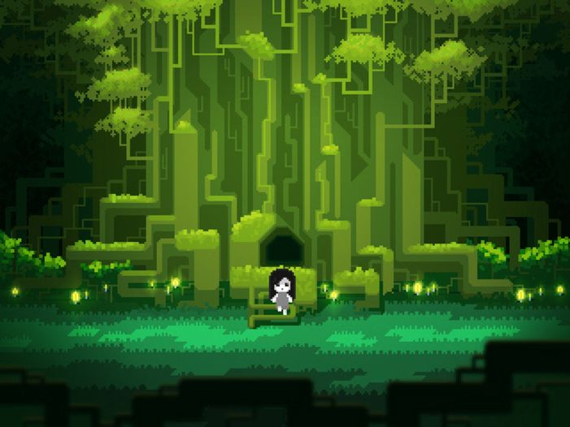 “games that feature blocky, poor unrealistic style graphics.”

Comedy

 “games that have comical features, such as jokes, funny graphics, or funny dancing / taunts”

Survival

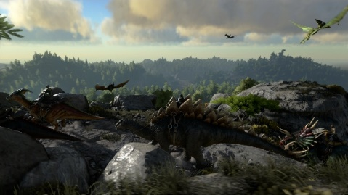 “Survival games are a subgenre of action video games that generally start the player off with minimal resources, in a hostile, open-world environment, and require them to collect resources, craft tools, weapons, and shelter, and survive as long as possible.”

Utilities

 “Utility software is system software designed to help analyze, configure, optimize or maintain a computer. In the gaming industry this could include benchmarks, or stress tests.”

VR

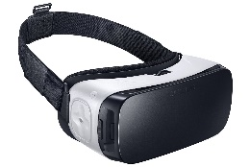 “Virtual reality gaming is where a person can experience being in a three-dimensional environment and interact with that environment during a game. This is an essential part of the game.”

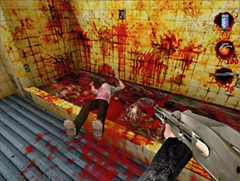Violent

“games that feature strong violence, such as behaviour involving physical force intended to hurt, damage, or kill someone or something.”

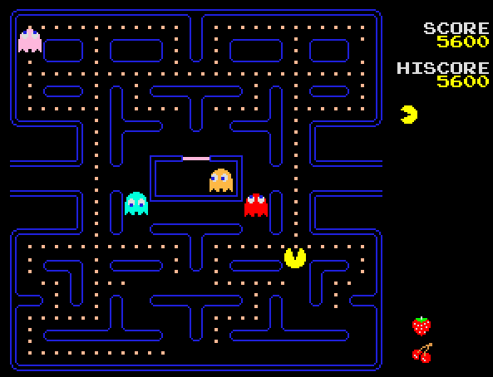Classic

“Retro gaming, also known as classic gaming and old school gaming, is the playing or collecting of older personal computer, console, and arcade video games in contemporary times.”